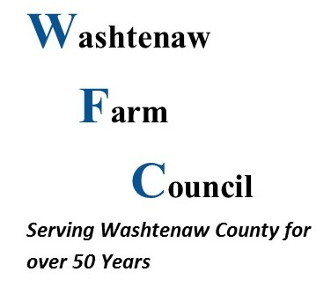 | Membership Application  Payment Method:  Cash Check  Annual 10 Years Lifetime  ($10 for 1Yr) ($50) ($100)  New Renewal

Applicant Information
Full Name: |  |  |  | Date:
 | Last | First | M.I.

Address:
 | Street Address | Apartment/Unit #

 | City | State | ZIP Code

Phone: |  | Email

Signature: |  | Date:

- The Annual Meeting is held each year on the second Monday of November.
- Monthly meetings of the Board of Directors are held each month on the second Monday.
- Meetings of the Board of Directors are open to the public and membership is not required to attend.

Washtenaw Farm Council Constitution and Bylaws state:
Article II, Section 1: Any person residing in Michigan who is above the age of eighteen (18) years shall be eligible for membership herein.
Article X, Section 2: A member must be enrolled and recorded at least thirty (30) days prior to the annual meeting, to be eligible to vote at such meeting.

Please complete the application and submit it to the Membership Chair at any meeting or by mailing to:

Washtenaw Farm Council
5055 Ann Arbor-Saline Road
Ann Arbor, MI 48103

For questions, please contact Jacob Henes at 734-429-3145

